Preschool Newsletter Room 28B 09/27/18

Friendly Reminders  - Please send your child to school in gym shoes every day  Books we are reading:  Neighborhood Song  The Gingerbread Man Loose in the School  We are reading about community helpers and school helpers.  Save the Date:  - 10/5 Institute Day, NO STUDENT ATTENDANCE  - 10/8 Columbus Day, NO STUDENT ATTENDANCE  - 10/8 Fire Prevention Week  - 10/22 Red Ribbon Week  - 10/25 Popcorn Day  - 10/31 Halloween Celebration Day | 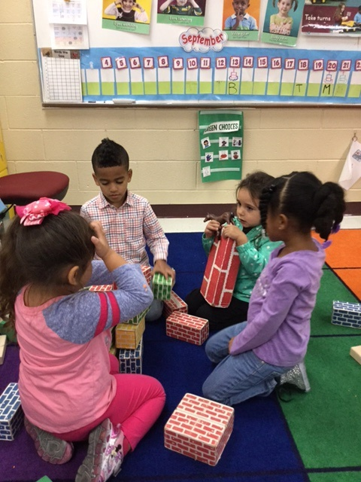  This Week:  Our focus was getting to know people in our school and in our community. We matched community helpers with their tools.  During small group we made a class book about what kind of job we want to do when we grow up. We drew about the job and labeled our picture. Students used words cards to help them label their job, or use phonetic spelling, spelling the letter sounds they hear. This student-made book will be added to our classroom library! Students also matched capital and lowercase letters, and connected numbers to items. Play doh group included lowercase letter stamps and fall cookie cutter shapes.  I look forward to welcoming you and your family to our Open House tonight.  Ms. Fierke, Mrs. Michelle, Mrs. Audrey  Troy Cronin Preschool, tfierke@troy30c.org,  815-577-7314x5201

