Preschool Newsletter Room 28B 09/19/18

- THANK YOU for sending the food items! We explored painting with them.  - Popcorn Day:If you would like to participate, please send your child’s .50 cents in a baggie labeled with their name. Please send the labeled baggie in their yellow folder.  Books we are reading:  Rice is Nice  Peanut Butter Fudge  The Gingerbread Man Loose in the School  We are reading about families and food.  Save the Date:  - 9/20 Picture Day  - 9/27 Popcorn Day and Back to School Night  - 10/5 Institute Day, NO STUDENT ATTENDANCE  - 10/8 Columbus Day, NO STUDENT ATTENDANCE  - 10/25 Popcorn Day | 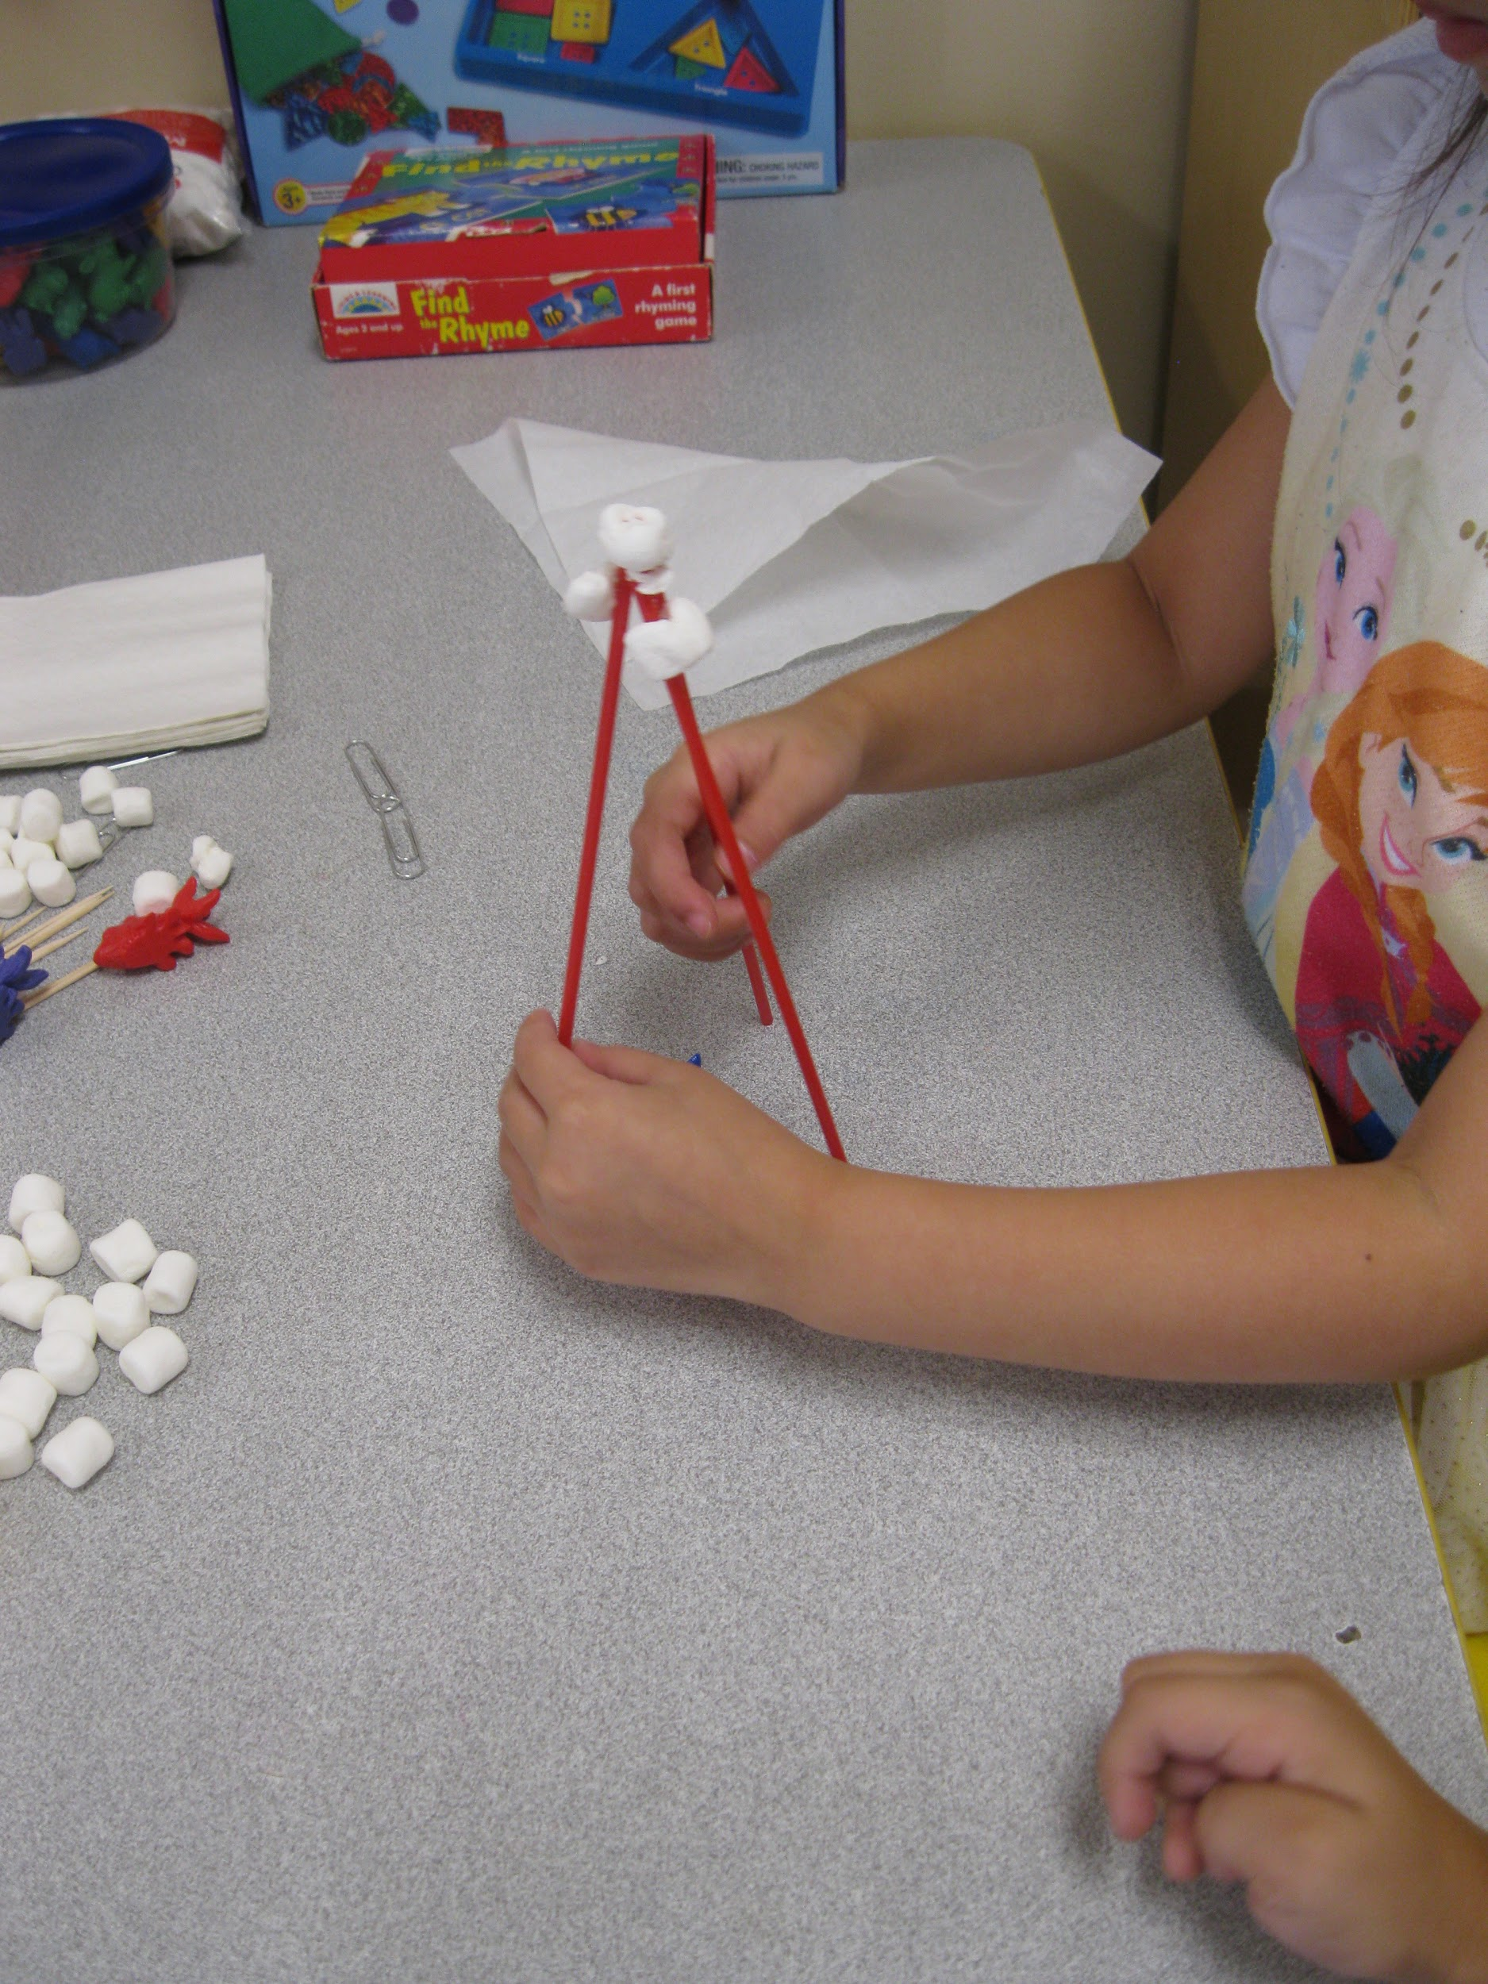  This Week:  Our focus was families and food. We retold Peeny Butter Fudge, taking turns talking about what happened on the pages.  Small Groups included many areas of learning. Students sorted rhyming words, listening for words that sound the same at the end. Using scales and food manipulatives, students compared and measured. They explored what happens when the scale tips up and down. We put on our art smocks and painted with the cut up food items. Play doh table included letter and number stamps.  Students engaged in a STEM (science technology engineering math) activity related to our school theme this year: camping. We used toothpicks, marshmallows, napkins, paper clips, animal toys, and straws to try and build a house an animal could live in.  Participation in any fundraisers are optional.  Ms. Fierke, Mrs. Michelle, Mrs. Audrey  Troy Cronin Preschool, tfierke@troy30c.org,  815-577-7314x5201

